Unique - Golden Bond Place Application Form


TCS London Marathon 2027
‘Unique’ - the Rare Chromosome Disorder Support Group holds a limited number of Golden Bond (guaranteed entry) places for the 2027 London Marathon. To ensure the cost of the places is covered and to maximise funds raised from this prestigious event, we require all runners offered and taking up one of our Golden Bond places to:

- Take part and fundraise exclusively for Unique

- Raise a minimum of £2,000 in sponsorship (excluding Gift Aid) for Unique

- Agree that should you fail to reach the above sponsorship target by race day (currently Saturday 24th and/or Sunday 25th April 2027), Unique will invoice you for the sum of £300 to cover the entry fee and that you will pay this fee within 30 days.

If you agree to the above and would like to apply for one of our Golden Bond places, please complete, sign & return this form by email by no later than Sunday 5th July . We aim to notify all applicants as soon as possible after this date whether they have been successful. Much as we would like to, as places are limited and in very high demand, we are unfortunately unable to offer a place to everyone who applies.

Personal Details:
Title: First Name: Surname:
Address:
Postcode: | Occupation:
Employer:

Date of Birth:
Telephone No:
Email:

Are you a member of Unique? Yes o No o

If Yes, please provides details of the child/adult affected by a rare chromosome disorder and their relationship to you:

If No, please tell us how you know about or heard of Unique:

Note. The data you provide is treated in confidence and used to administer Unique’s London Marathon ‘Golden Bond’ places.

Have you applied/Will you be applying to the official ballot for the London Marathon 2027?

o Yes o No, I have not applied to the official ballot

If successful in gaining a place, would this be the first time you will have taken part in a London Marathon? Yes o No o

If no, please give details:

Have you completed other marathons/long distance runs? Yes o No o

If Yes, please provide details:

Are you planning to run with a group of friends or colleagues? Yes o No o
If Yes, please provide details here:

Have you fundraised for Unique before? Yes o No o

If Yes, please provide details here:

Will your employer/company support you? Yes o No o

If yes, please provide details of the ways your company will support you e.g. through a match-giving scheme etc

What would your sponsorship target (excluding Gift Aid) be? £

Please outline the ways in which you will aim to raise your sponsorship target for Unique, remembering that we require you to raise a minimum of £2,000. Please give as much detail as possible:

As part of your commitment, we require you to set up and use an online sponsorship page. We will send you instructions for setting a page up. Please tick the box to indicate your agreement: Yes o No o

Please share the reasons why you would like to run the 2027 London Marathon for Unique:

If you are unsuccessful in gaining one of our London Marathon places, would you be interested in hearing about other ways/events in which you could fundraise for Unique?

Yes o No o

Important - Your Declaration:

I agree that if I am offered and accept a Golden Bond place for the 2027 London Marathon by Unique (the Rare Chromosome Disorder Support Group), I will:

- Take part and fundraise exclusively for Unique and no other charity.

- Raise a minimum of £2,000 in sponsorship for Unique (excluding Gift Aid) in return.

I understand and agree that if I cannot prove that I have raised £2,000 before the date of the event, (currently Saturday 24th and/or Sunday 25th April 2027) Unique will invoice me for the sum of £300 to cover the cost of the place and I will settle this invoice within 30 days of the invoice date.

I undertake that any money raised by my sponsors outside of an online sponsorship page will be transferred exclusively to Unique without undue delay.

Signature: Date:

Print Name:
Please complete, sign and return to our Engagement and Communications Officer on matt@rarechromo.org or send to:
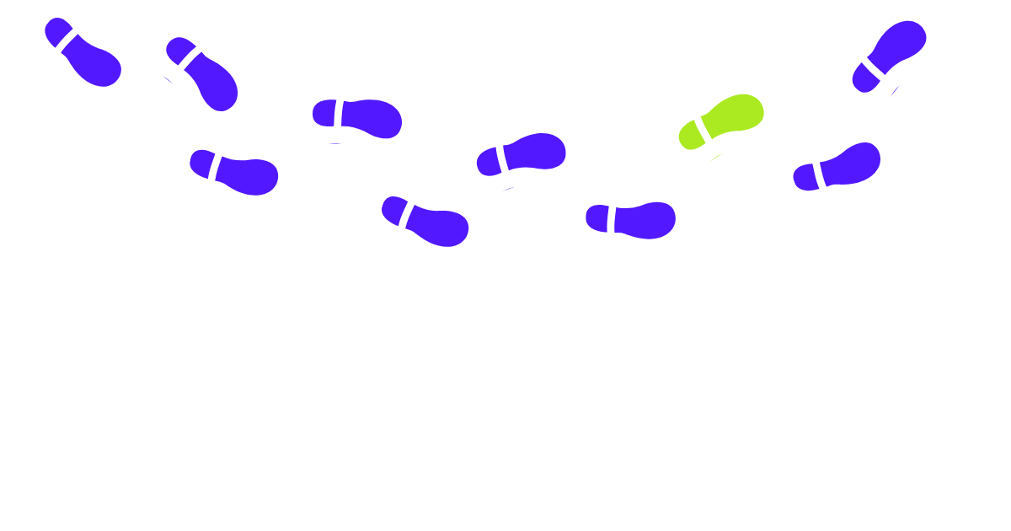
Unique
The Stables
Station Road West
Oxted
Surrey
RH8 9EE

